**NAME:KANISHKA TAK**

**Assignment 1**

1. Assign your Name to variable name and Age to variable age. Make a Python program that prints your name and age.

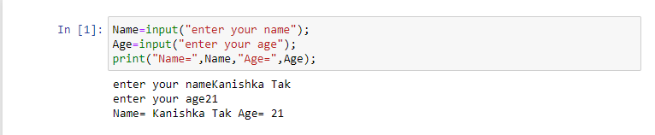

1. X="Datascience is used to extract meaningful insights." Split the string

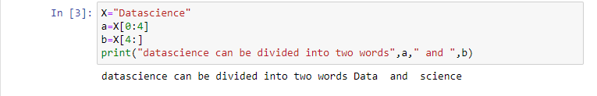

1. Make a function that gives multiplication of two numbers

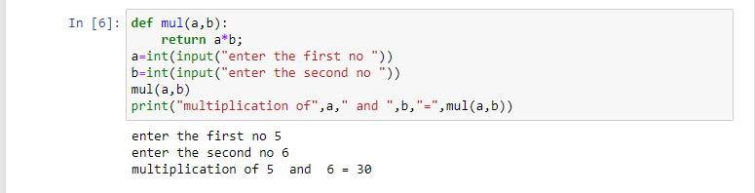

1. Create a Dictionary of 5 States with their capitals. also print the keys and values.

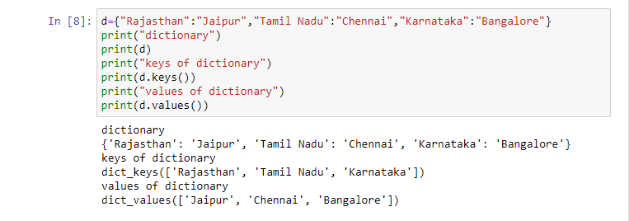

1. Create a list of 1000 numbers using range function.

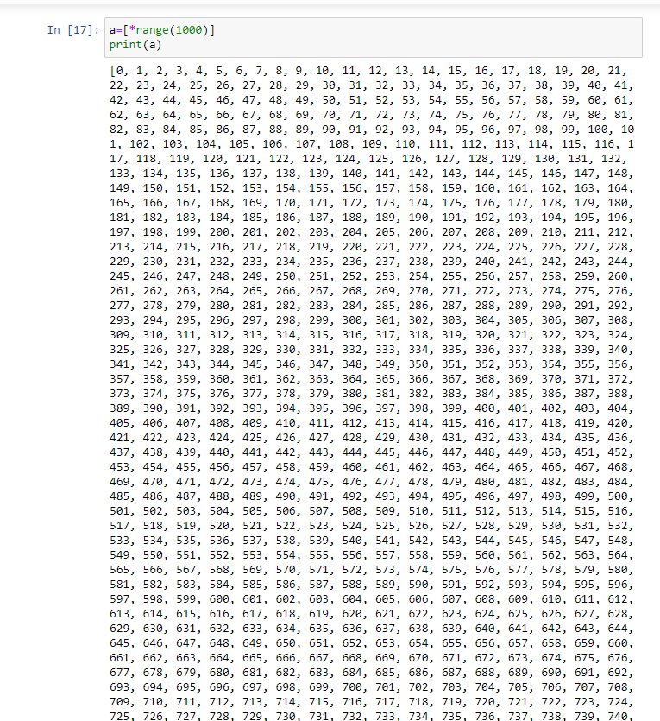

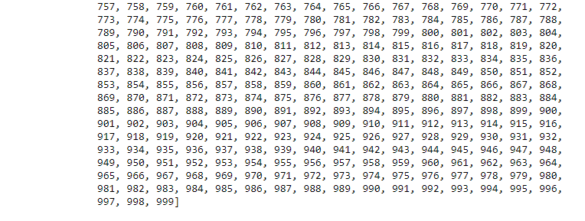

1. Create an identity matrix of dimension 4 by 4

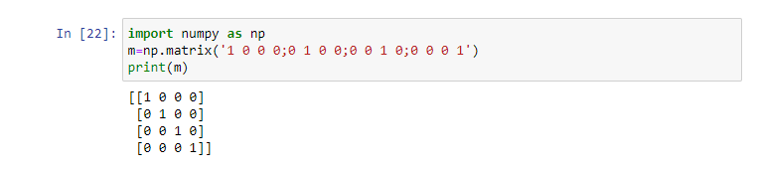

1. Create a 3x3 matrix with values ranging from 1 to 9

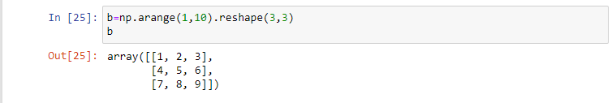

1. Create 2 similar dimensional array and perform sum on them.

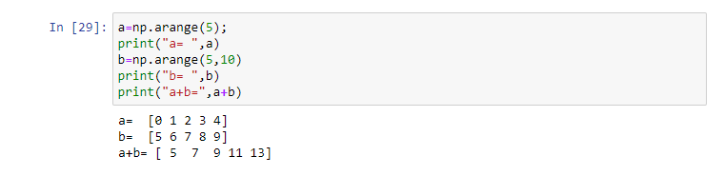

1. Generate the series of dates from 1st Feb, 2023 to 1st March, 2023 (both inclusive)

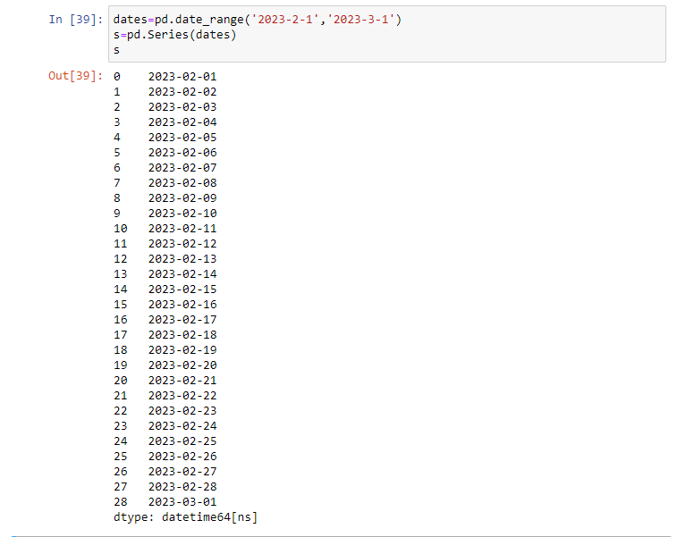

1. Given a dictionary, convert it into corresponding dataframe and display it dictionary = {'Brand': ['Maruti', 'Renault', 'Hyndai'], 'Sales' : [250, 200, 240]}

